Condo Daily Report 9-17-21

Friday

* Okta
  + Snowflake integration
    - I am trying to go through saml setup with snowflake step by step so I can be sure to have a detailed list about what exactly I had done
      * This will include values and queries input
    - 
      * Above is the subdomain with the value **maa23857-main**
    - Put that value here
      * 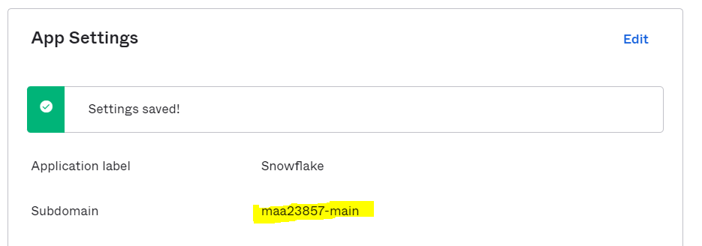
    - Targeted Users were in assignments
    - Moved to snowflake
      * Completed the saml_identity_provider query
        + 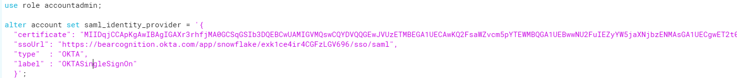
      * Tested snowflake initiated sso
        + 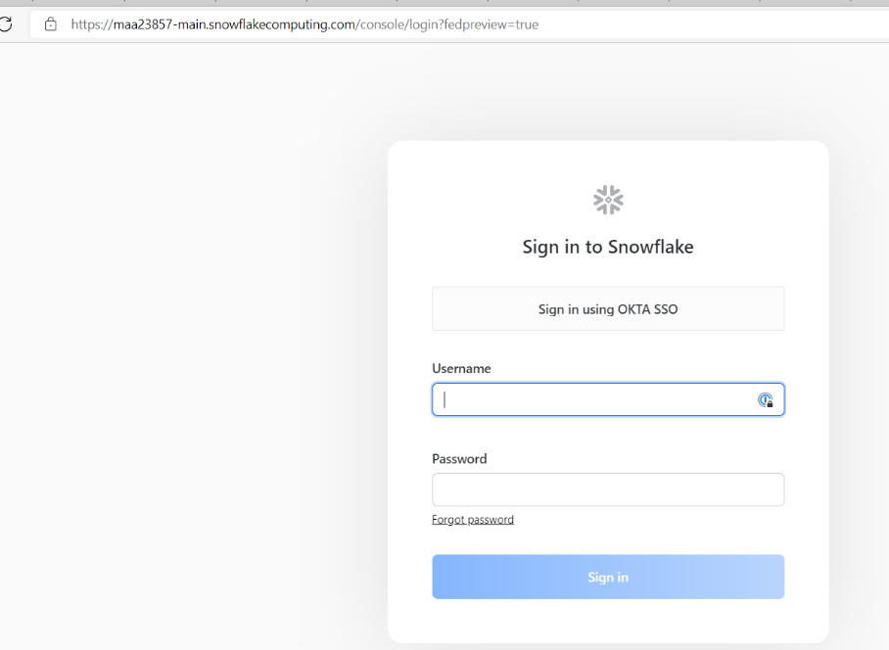
      * ­set_sso_login query
        + 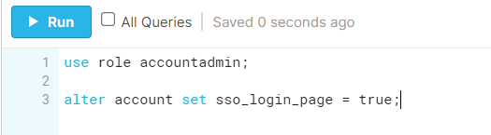
      * Attempted SSO
        + 
        + Got this error message again
      * Went down to see that we needed to add an accepted attribute
        + 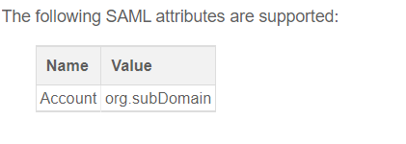
      * Went to add attribute and got this error
        + 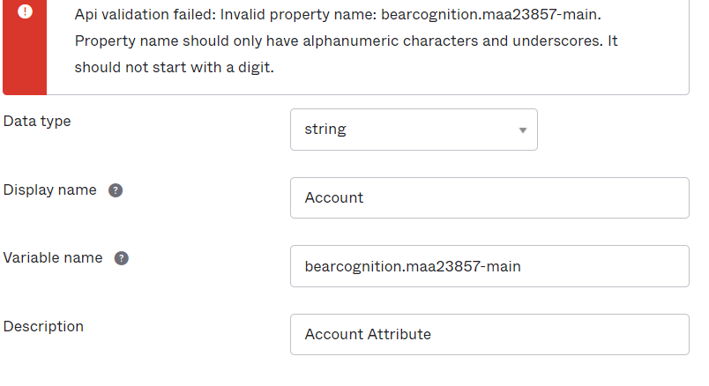
      * Went on and realized something about snowflake users
        + 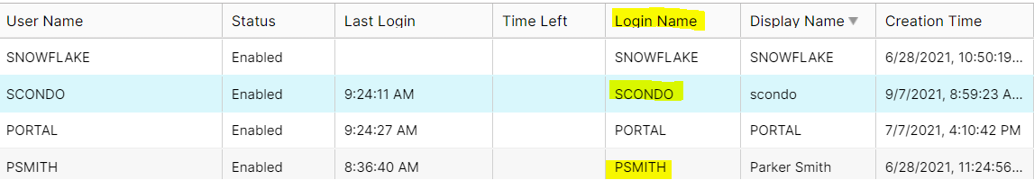
        + all login names were upper case email prefix’s and in okta we just had it set to email prefix’s

I thought that maybe it was a username match error

* + - * I made a custom username format field that turns okta email prefix’s to all caps
        + 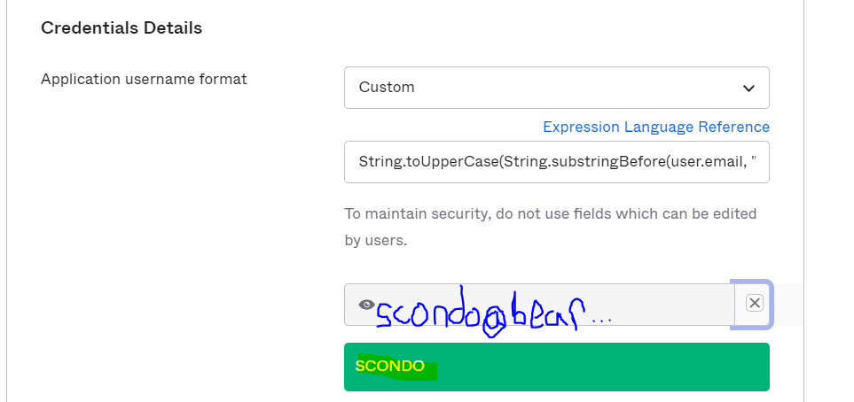
        + This didn’t work either
      * I made a detailed list as seen above with graphics to send to snowflake support in hopes of a resolution.
* Cloudformation
  + Full stack
    - Tried to develop full stack
      * Struggled to ref the stack names for the passed values
        + This is a problem because the logical stack names are necessary to pass the exported values
      * Found a way to potentially resolve this problem using the cloudformatin:Macro solution
        + This is going to be difficult because I need to locate the string and format it in the way that I want
      * I was able to manipulate a given string to make it all caps using a macro supplied by AWS
        + I am planning on tweaking their strip method to make a substring method